**Covariance** and **Correlation** are two mathematical concepts which are commonly used in the field of probability and statistics. Both concepts describe the relationship between two variables.

**Covariance –**

1. It is the relationship between a pair of random variables where change in one variable causes change in another variable.
2. It can take any value between -infinity to +infinity, where the negative value represents the negative relationship whereas a positive value represents the positive relationship.
3. It is used for the linear relationship between variables.
4. It gives the direction of relationship between variables.

**Formula –**  
**For Population:**

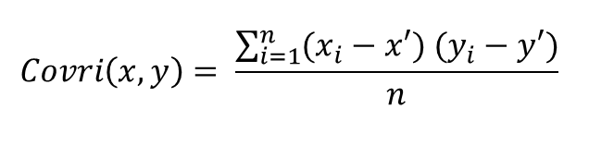

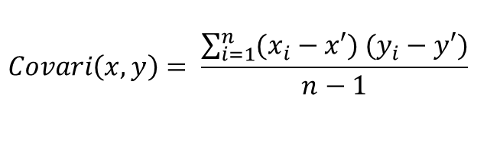

Here,  
x and y = mean of given sample set  
n = total no of sample  
xi and yi = individual sample of set

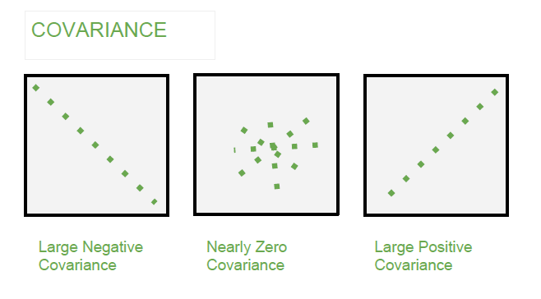

**Correlation –**

1. It show whether and how strongly pairs of variables are related to each other.
2. Correlation takes values between -1 to +1, wherein values close to +1 represents strong positive correlation and values close to -1 represents strong negative correlation.
3. In this variable are indirectly related to each other.
4. It gives the direction and strength of relationship between variables.

**Formula –**

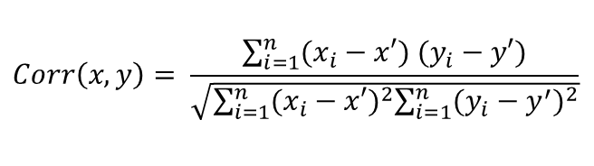

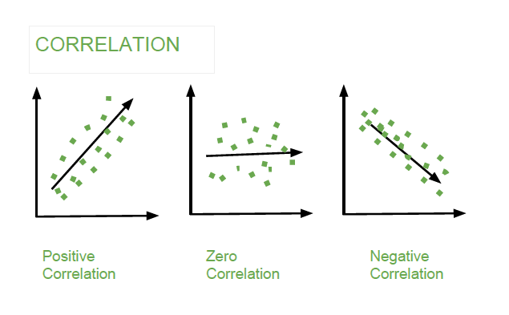

**Covariance versus Correlation –**

| **Covariance** | **Correlation** |
| --- | --- |
| Covariance is a measure of how much two random variables vary together | Correlation is a statistical measure that indicates how strongly two variables are related. |
| involve the relationship between two variables or data sets | involve the relationship between multiple variables as well |
| Lie between -infinity and +infinity | Lie between -1 and +1 |
| Measure of correlation | Scaled version of covariance |
| provide direction of relationship | provide direction and strength of relationship |
| dependent on scale of variable | independent on scale of variable |
| have dimensions | dimensionless |

Multicolinearity:

**Multicollinearity** is the presence of high correlations between two or more independent variables (predictors). It is basically a phenomenon where independent variables are correlated.

**Detecting and Removing Multicollinearity**